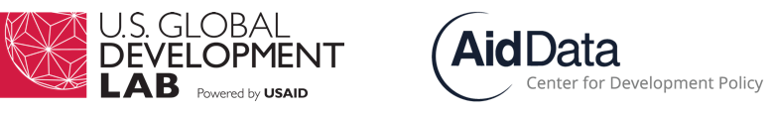

ARC Membership Application

The AidData Research Consortium (ARC) is an interdisciplinary network of faculty and analysts across the world who are committed to using subnationally georeferenced development finance data to advance research frontiers and inform development policy-making and decision-making. Many ARC members are interested in using sub-national geocoded aid data to address applied/policy-oriented problems in partnership with USAID and other development agencies. Benefits of ARC membership include: early access to preliminary sub-national geocoded development finance datasets; access to competitive funding for ARC sponsored conferences; direct access to and collaboration with development policymakers; communications support for dissemination of research findings; and eligibility to apply for Research Award and Strategic Research Response research funds. To apply for membership in the ARC, prospective members should submit the form below and a current CV. All ARC membership forms for team members should be sent to the corresponding PI and bundled with the final EOI submission. If you have any questions about the ARC or the membership application, please email ARC@aiddata.org.

1. Please indicate research interests in the following areas (1 = low interest, 5 = high interest):

Conflict Mitigation | Democracy & Governance | Economic Growth | Environment & Climate Change | Food Security & Nutrition

Global Health | Humanitarian Response | Child & Maternal Health | Energy Access | Gender

Child Literacy | Financial Inclusion | Water Solutions | Education | Other (please specify and indicate level of interest)

2. Please check regional areas of interest and note individual focus countries (if applicable):

- [ ] West Africa:
- [ ] East Africa:
- [ ] Sub Saharan Africa:
- [ ] Central America:
- [ ] South America:
- [ ] Middle East/North Africa:
- [ ] Asia Pacific:
- [ ] Central Asia:
- [ ] East Asia:
- [ ] South Asia:

3. Please provide a link to your CV or provide as an attachment.

